Steps for creating your Capstone project box folder:

1. Navigate to: <https://ibm.ent.box.com/folder/0>
2. In the right navigation click ‘New’ - > Folder

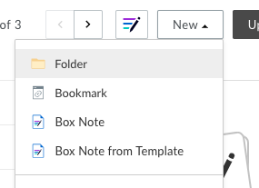

1. Name your folder ‘Your Name – Capstone Project’ and click ‘Create’

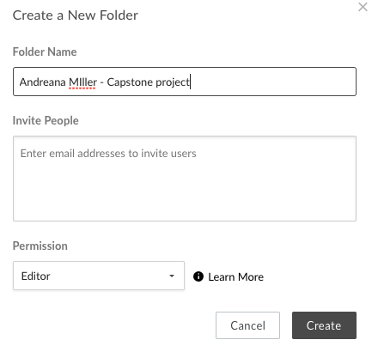

1. Your folder has been created. Click the … and ‘Settings’

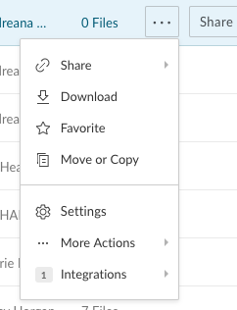

1. Under the Collaboration section click the box that says, “Allow anyone who can access this folder from a shared link join as a Collaborator” and click Save Changes

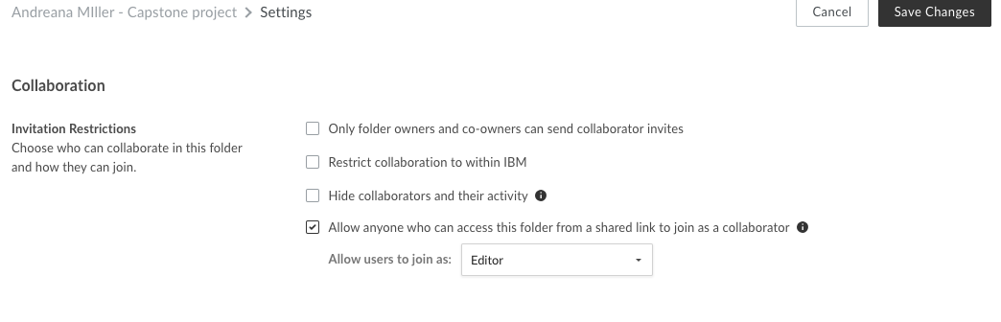

1. Add the following to your box folder:

* Operating Report
* ReadMe
* Your code

1. Click ‘Share this Folder’ -> Get Shared Link

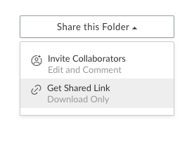

1. Change the access type to ‘People with this Link’

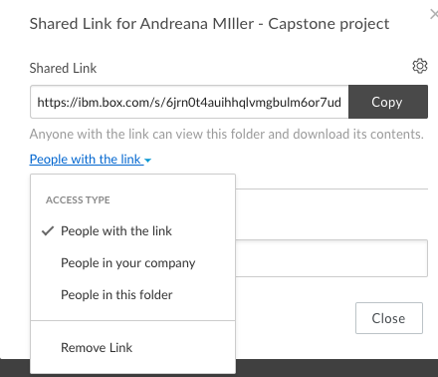

1. Copy the link and paste that in your submission form